Experiment 8: Create a Pivot Table and Find Item-wise Units Sold
import pandas as pd

# Sales Data
data = {
'OrderDate':['1-6-18','1-23-18','2-9-18','2-26-18','3-15-18',
'4-1-18','4-18-18','5-5-18','5-22-18','6-8-18',
'6-25-18','7-12-18','7-29-18','8-15-18','9-1-18',
'9-18-18','10-5-18','10-22-18'],

'Region':['East','Central','Central','Central','West','East',
'Central','Central','West','East','Central','East',
'East','East','Central','East','Central','East'],

'Manager':['Martha','Hermann','Hermann','Timothy','Timothy',
'Martha','Martha','Hermann','Douglas','Martha',
'Hermann','Martha','Douglas','Martha','Douglas',
'Martha','Hermann','Martha'],

'SalesMan':['Alexander','Shelli','Luis','David','Stephen',
'Alexander','Steven','Luis','Michael','Alexander',
'Sigal','Diana','Karen','Alexander','John',
'Alexander','Sigal','Alexander'],

'Item':['Television','Home Theater','Television','Cell Phone',
'Television','Home Theater','Television','Television',
'Television','Home Theater','Television','Home Theater',
'Home Theater','Television','Desk','Video Games',
'Home Theater','Cell Phone'],

'Units':[95,50,36,27,56,60,75,90,32,60,90,29,81,35,2,16,28,64],

'Unit_price':[1198,500,1198,225,1198,500,1198,1198,
1198,500,1198,500,500,1198,125,58.5,500,225],

'Sale_amt':[113810,25000,43128,6075,67088,30000,89850,
107820,38336,30000,107820,14500,40500,
41930,250,936,14000,14400]
}

df = pd.DataFrame(data)

pivot = pd.pivot_table(
df,
values='Units',
index='Item',
aggfunc='sum'
)

print("Item Wise Units Sold")
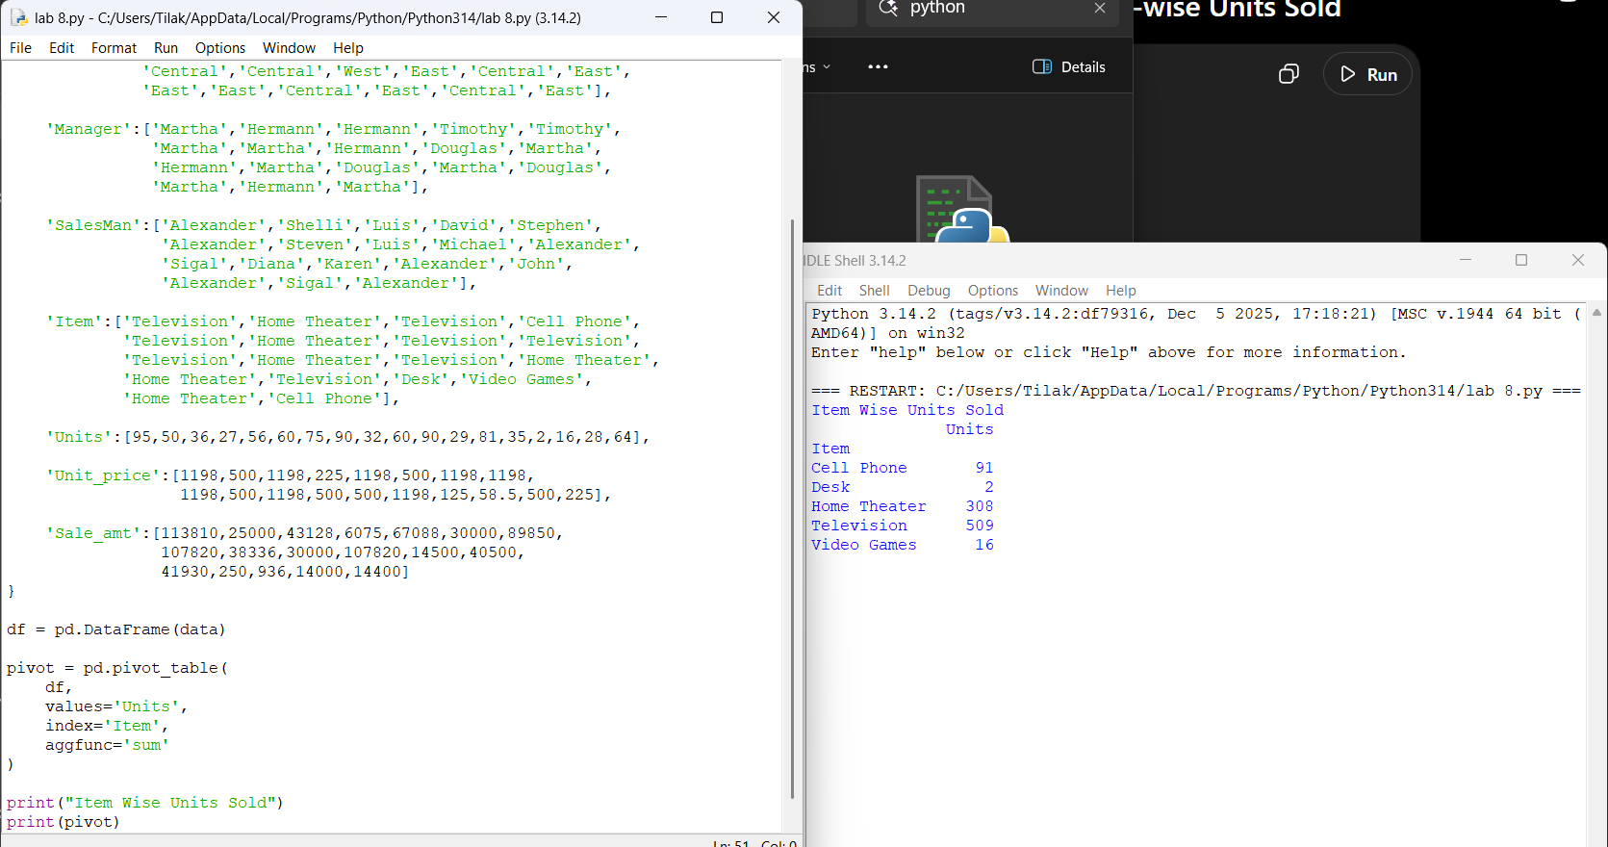
print(pivot)

Experiment 9: Pivot Table
import pandas as pd

df = pd.read_excel(r"C:\Users\Tilak\OneDrive\Documents\sales_data.csv.xlsx")

print(df.head())
print(df.columns.tolist())

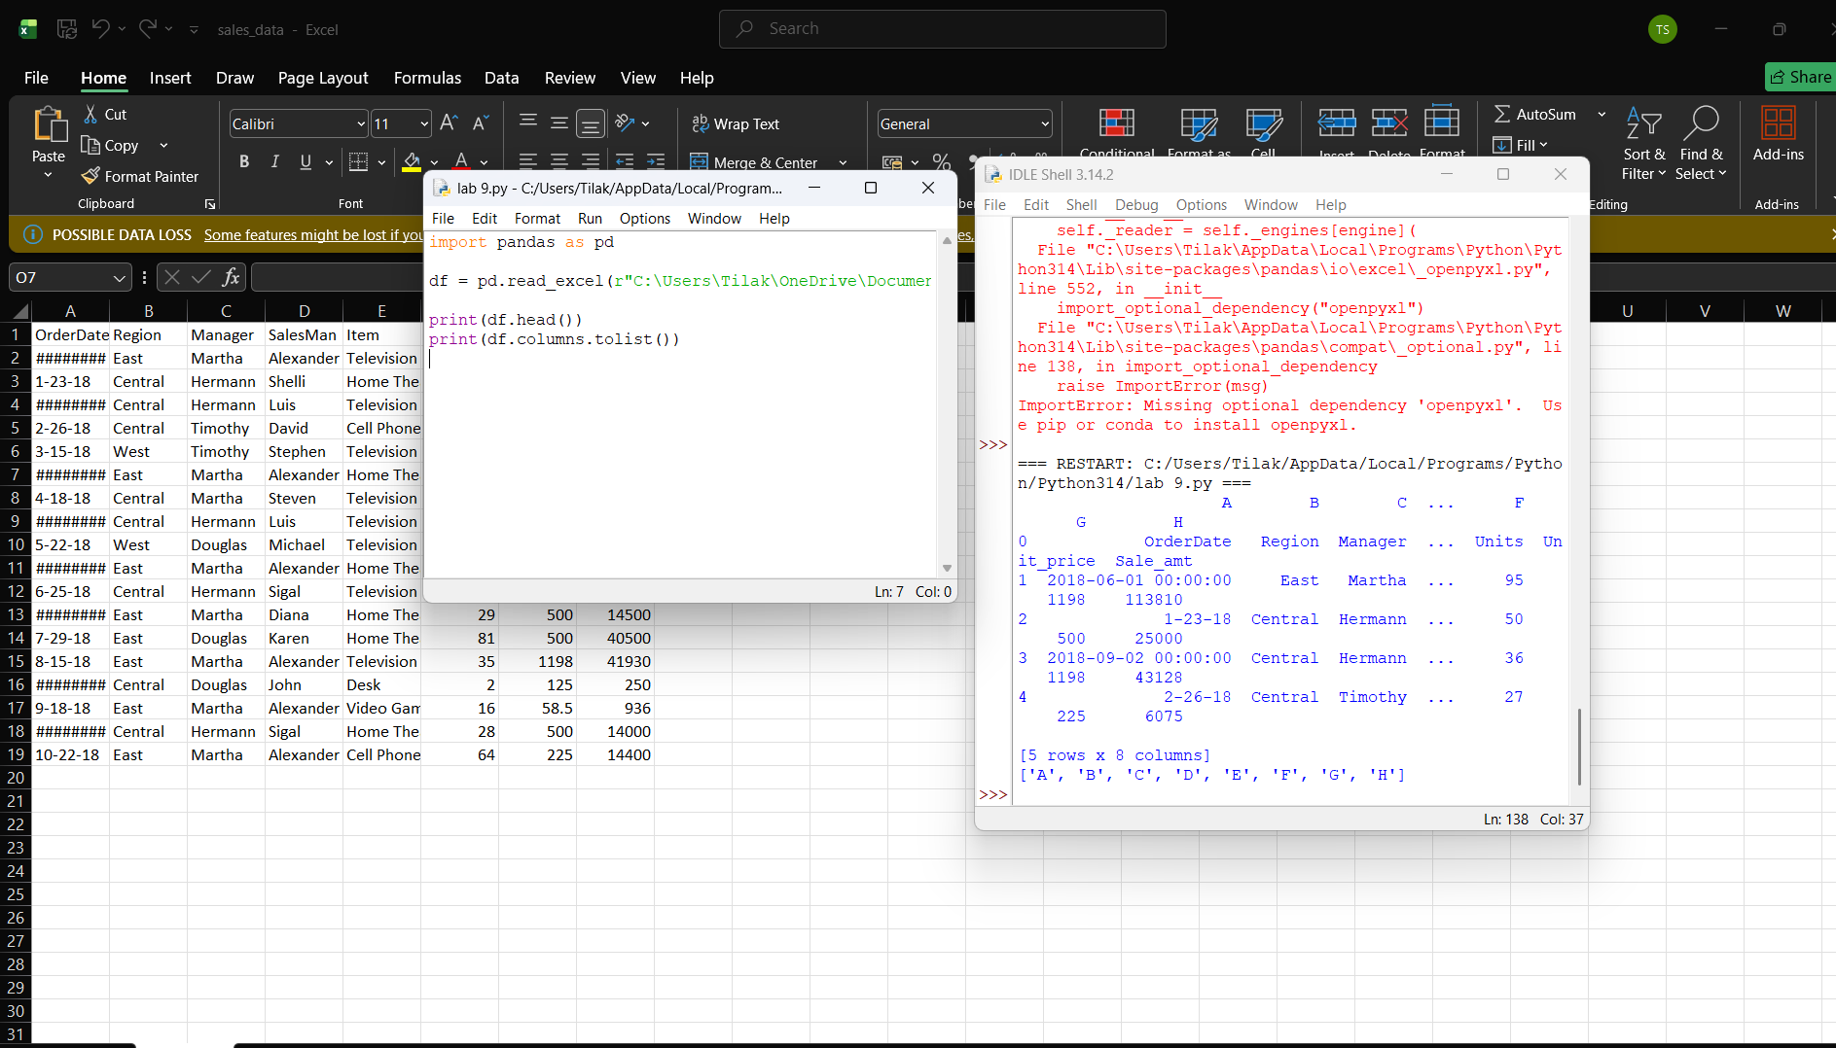

Exp-10 Representing Negative values in RED
import pandas as pd
import numpy as np
import webbrowser

np.random.seed(10)

df = pd.DataFrame(
np.random.randint(-50, 51, (10, 4)),
columns=["A", "B", "C", "D"]
)

def color_negative(val):
if val < 0:
return "color:red"
return "color:black"

styled = df.style.map(color_negative)

styled.to_html("negative_red.html")

webbrowser.open("negative_red.html")

print("HTML file opened in browser.")

